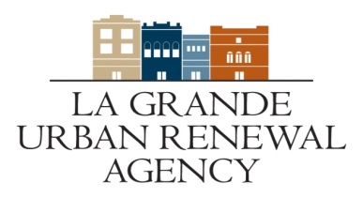
Call for Projects
Early Start Form

Business Name:___________________________________
Applicant:______________________________________
Address:_______________________________________

Funding for projects will not be available until after July 1, 2021. If you desire to begin your project prior to July 1, 2021. Please sign below and return with your application submittal. Any authorization to proceed ahead of the award is at the applicant’s risk as there is no guarantee of Urban Renewal funding.

______________________________________
Anticipated start date

______________________________________ ____________________
Signature Date

This form is not an award and you have not been approved for any funding.

