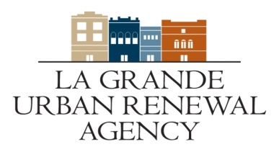
Call for Projects 2021
Application checklist

Business Name:___________________________________
Type of Business:________________________________________
Applicant:______________________________________
Address:_______________________________________

- Completed Grant Application
- Business Plan

- Actual Bids

- Within word limit Y or N

- Letter of authorization from building owner, if owner is not applicant

- Current Photograph of the building

- Historic photos (if available)

- Cost estimate breakdown and sources of funds

- Documents Demonstrating Sources of Funds

- Narrative and/or visual description of project

- Floor Plans, drawings and/or site plan

- Current building use, including tenant (not residential) names and contact information (on intake form)

- Project timeline

- Assessor records verifying ownership

- Community Comment

