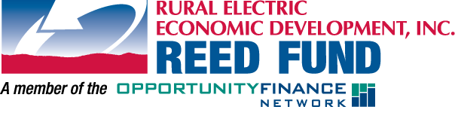
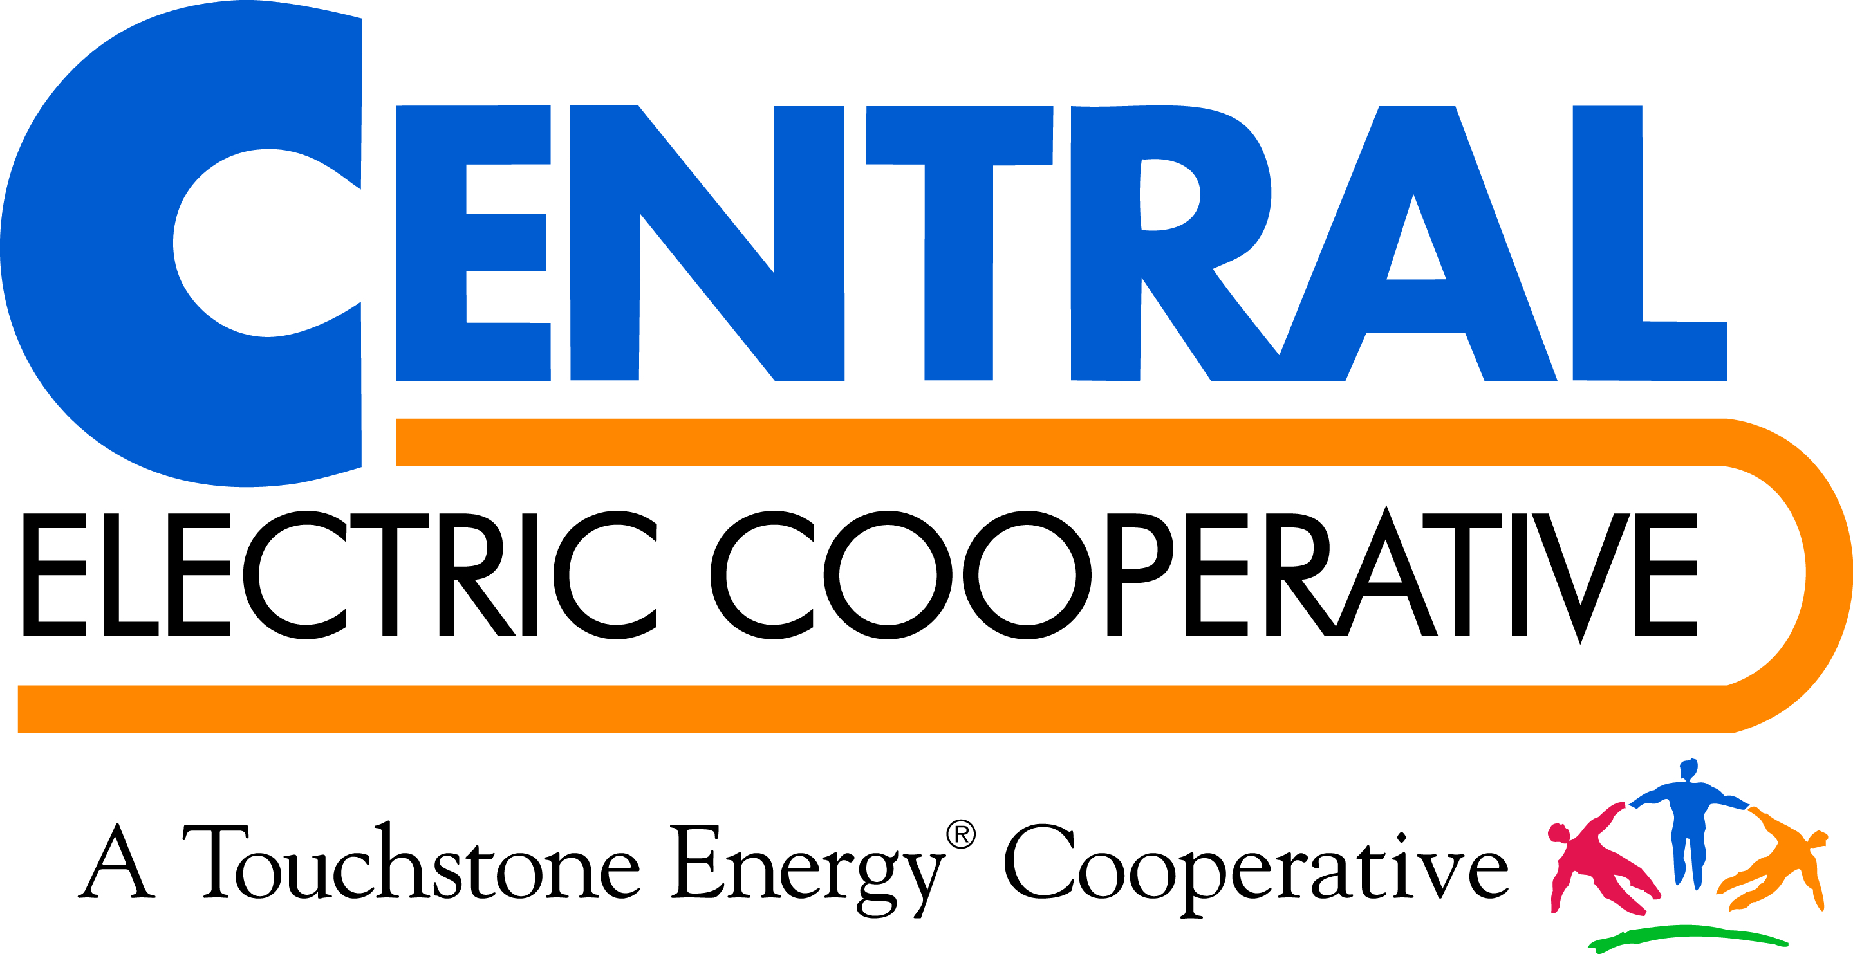

NEWS RELEASE
For immediate Release: November 20, 2014
Contact: Loren Noess, General Manager
Central Electric Cooperative
Office: 800.477.2892
lnoess@centralec.coop
Horizon Health Care receives loans for new
Woonsocket Community Health Center
WOONSOCKET — The new Horizon Health Care, Inc. (Horizon) medical clinic in Woonsocket has benefitted from a pair of low-interest loans through Central Electric Cooperative and the Rural Electric Economic Development (REED) Fund. Central Electric, a local Touchstone Energy® Cooperative, used the Rural Economic Development Loan and Grant (REDLG) program to secure financing for the project through the U.S. Department of Agriculture.
“We’re so pleased to be able to help Horizon in this way,” said Loren Noess, Central Electric Cooperative’s general manager. “A big part of our mission is to build stronger communities and helping to increase access to good, affordable health care is one way we can keep our rural towns strong.”
The REED Fund works with other local lenders to assist in financing economic development projects in eastern South Dakota and western Minnesota.
“We’ve been fortunate to assist Horizon in a number of our rural communities and it’s making a real difference in the lives of people in rural areas,” said REED Fund manager Linda Salmonson. “Working closely with our member cooperatives, the REED Fund looks for ways we can positively impact people’s lives and build a stronger economic future in our area.”
The 2,800-square-foot clinic opened its doors to patients Sept. 27 and held its grand opening Oct. 15. The two loans closed Nov. 20. The medical facility serves the city of Woonsocket and surrounding areas and includes three exam rooms, a nurses’ workstation, a minor procedure room, and rooms for x-ray, telemedicine room, and laboratory work.
Horizon operates 13 medical and four dental facilities within the surrounding areas and throughout the state of South Dakota.

